Sunday | Monday | Tuesday | Wednesday | Thursday | Friday | Saturday
 |  |  |  |  |  | 1
2 | 3 | 4 | 5 | 6 | 7 | 8
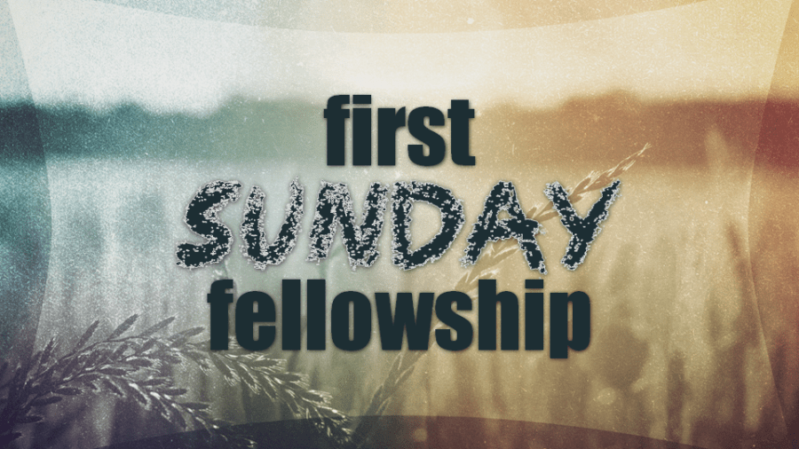  Joshua Crank  Melissa Wulf | M/M Wade Martin  Charlotte Herring |  | Dinner & Classes  5:45 Dinner  6:15 Odyssey  6:15 Youth Classes  6:30 Adult Classes  M/M Jackie Boyd  M/M Chad Boyett  Dylan Kennedy | CELEBRATE RECOVERY  5:30 Meal  6:00 Worship  7:00 Small Group |  | M/M Joshua Varner  Noah Boyd
9 | 10 | 11 | 12 | 13 | 14 | 15
 | M/M Bobby Clark | M/M Chris Crank  Regina McMillan | Dinner & Classes  5:45 Dinner  6:15 Odyssey  6:15 Youth Classes  6:30 Adult Classes  Shirley Williams  Wil Wulf | CELEBRATE RECOVERY  5:30 Meal  6:00 Worship  7:00 Small Group | Women’s Connect Group 6:00 p.m. | Krystian Alford
16 | 17 | 18 | 19 | 20 | 21 | 22
Ministry Meetings  Thomas Connect Group 5:00 p.m.  Womack Connect Group 5:00 p.m. |  | Phyllis Young | Dinner & Classes  5:45 Dinner  6:15 Odyssey  6:15 Youth Classes  6:30 Adult Classes | CELEBRATE RECOVERY  5:30 Meal  6:00 Worship  7:00 Small Group | Middle/High School Bowling Night  7:00 p.m.@  All Star Lanes  Alice Buckley | Camille Cates
23 | 24 | 25 | 26 | 27 | 28 | 29
Bailey/Touchet  Connect Group  5:00 p.m.  Bobby Langston |  |  | Dinner & Classes  5:45 Dinner  6:15 Odyssey  6:15 Youth Classes  6:30 Adult Classes  M/M Gary Boswell | CELEBRATE RECOVERY  5:30 Meal  6:00 Worship  7:00 Small Group | M/M Roy Kennedy | Movie Day (K-5th) at Westview  1:00-3:00 p.m.  Ashley Timler
30 | 31
Camp Clearwater Work Week  (May 30th – June 3rd)  David Wright |  

